# Compodoc

TABLE OF CONTENTS

Introduction 3

Need of Compodoc 3

Features 3

Implementation 4

Angular Project Creation 4

Installation 5

Configuration 5

Generating the documentation 6

Exploring the documentation 7

Additional Features 23

Themes 23

Live Example Tab 24

Conclusion 25

SRILAKSHMI SS



# Introduction

During angular project developments application grows in the course of time. Developers prefer coding rather than writing documentation for other developers. As a result, it is very difficult to keep track of each module and explain the source code to other team members. Hence it is good to have a self-explanatory documentation at hand so that others can understand the project structure on their convenient time. To have this self-explained document we have a tool named “**Compodoc**”. Compodoc is a tool which automatically generates the documentation for angular applications. This tool gives the complete project documentation in HTML format for all the components, modules, injectables, directives, interfaces, routes, pipes and classes of the project. It auto generates static documentation based on the code with one command.

**Need of Compodoc**

* Compodoc helps the angular developers in providing a simple and clear documentation of their application.
* Co-workers can easily understand the features, project structure of your application.
* Open source

**Features**

* Supports Angular, Nest, Stencil
* Simple design – navigation on left side and details on right side
* Many Languages support
* Search facility – Easily find information
* Open source
* Automatic table of contents
* Display each API by type: modules, component, directive, service, class, pipe
* No typescript compilation
* Documentation coverage report of project
* Dark mode support
* Various themes
* JSDoc light support – support of @param, @returns, @ignore tags
* Offline tool using Node.js on computer

# IMPLEMENTATION

**Angular project creation**

1. Create a new angular project

ng new HotelManagementSystem

1. Create some components, directives, services with ng generate commands

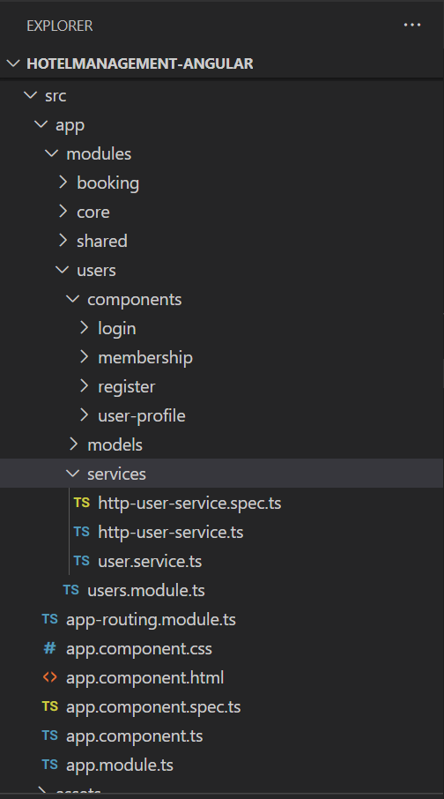

**Installation**

Installing compodoc either globally or save it as development dependencies.

Global installation



or

Dev-dependency



**Configuration in package.json**

Add the following script in package.json

Script: "compodoc":"npx compodoc -p tsconfig.json -w -s".

This script will be executed when you run compodoc in terminal.

-w = watch mode ( watch for changes and update server, always generate a new version if code changes)

-s = serve the documentation

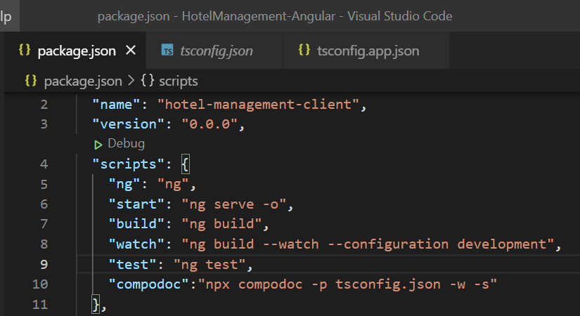



**Generating the documentation**

1. To create the documentation of your project, execute the below command in terminal



1. You will see the below details in terminal that include the project statistics, preparation of components, modules, directives, injectables, interceptors, routes, pipes, etc. Then it will process the documentation coverage.

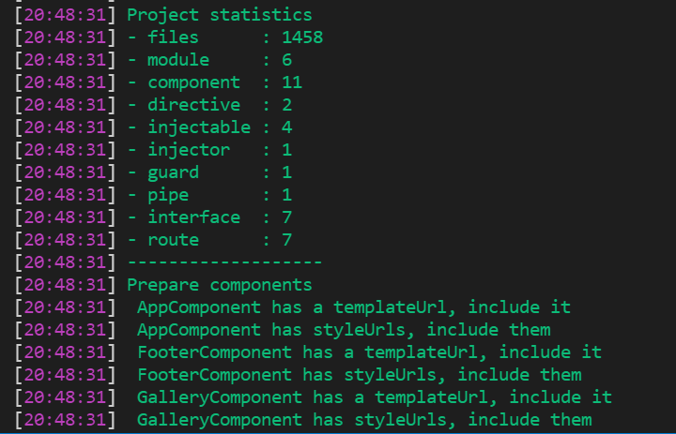

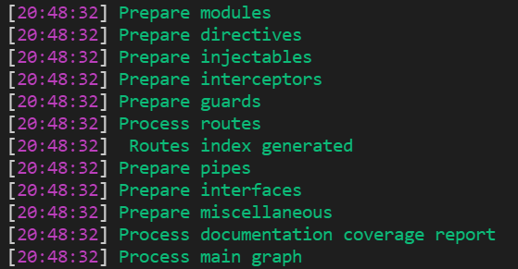

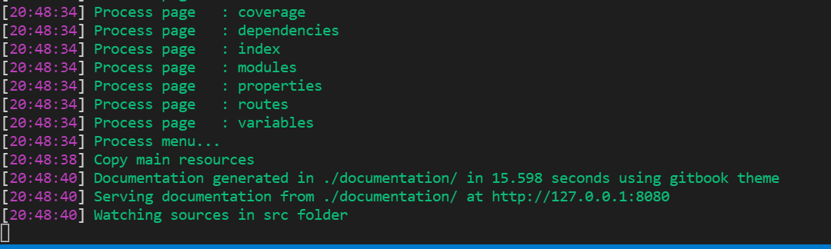

1. Next you will get a folder named “**documentation**” at the root of the project which includes separate sub folders for components, directives, guards, injectables(services), interfaces, pipes, styles, fonts, images, graph, js and miscellaneous. Other files including coverage.html, index.html, dependencies.html, modules.html and properties.html are generated. The documentation served on <http://127.0.0.1:8080>. Expanded view of components folder is given in the right side of the screen shot below.

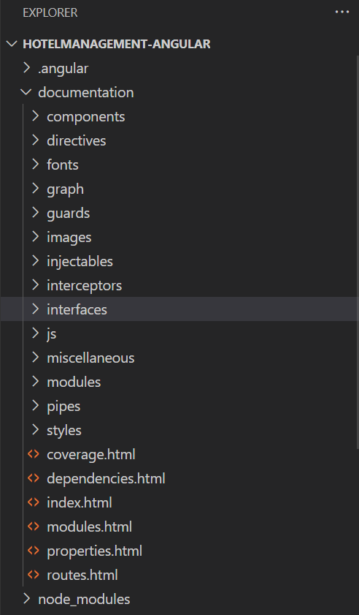 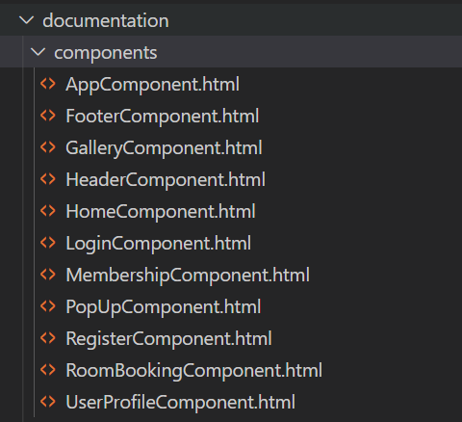

**Exploring the documentation**

Open the generated documentation <http://127.0.0.1:8080>. It opens the Readme page.

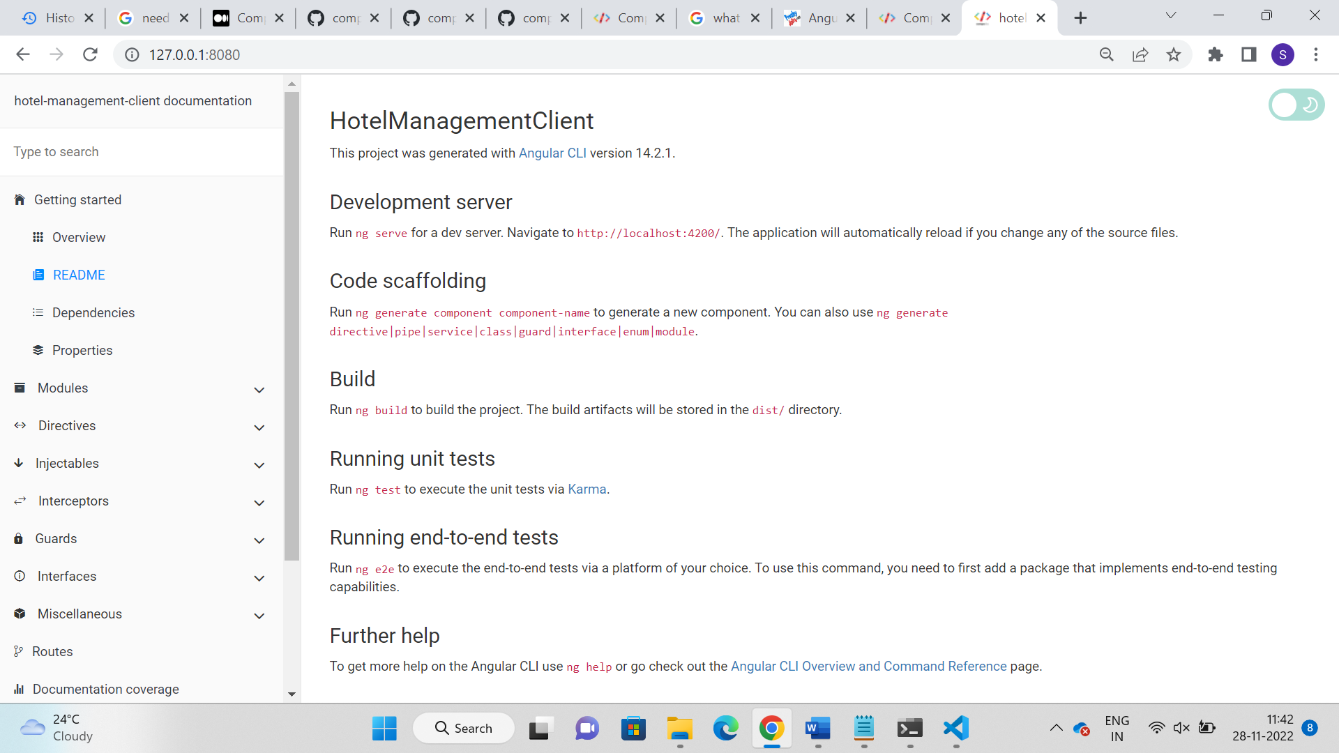

1. **Overview:**

The overview tab gives the overview about your project modules which includes the count of components, modules, directives, injectable services, pipes, routes, interfaces and guard with zoom features.

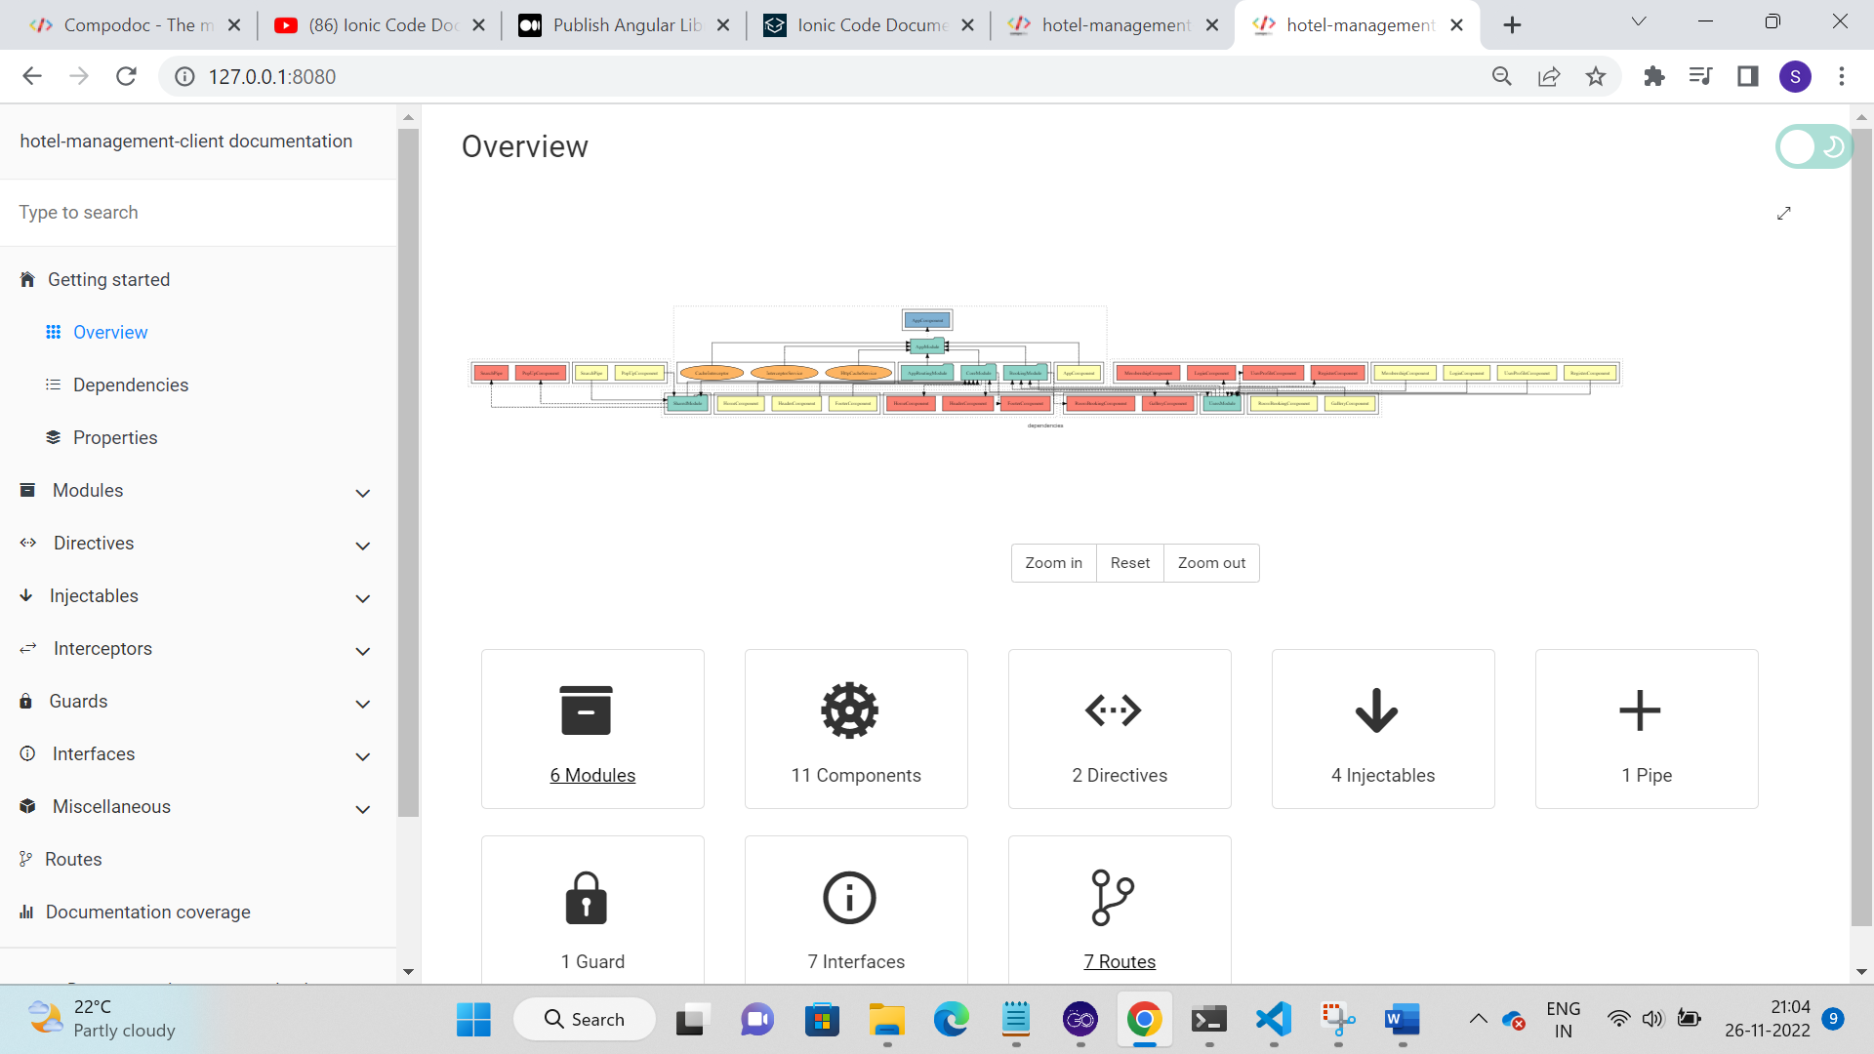

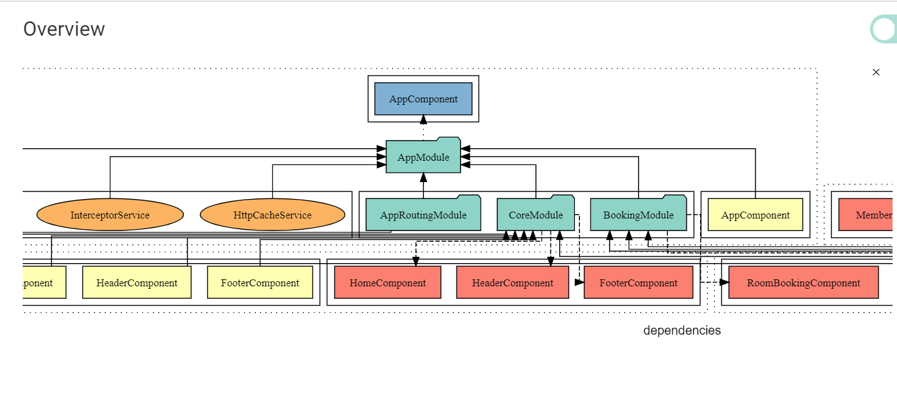

1. **Dependencies –** include the list of dependencies with the versions as it is in package.json file.

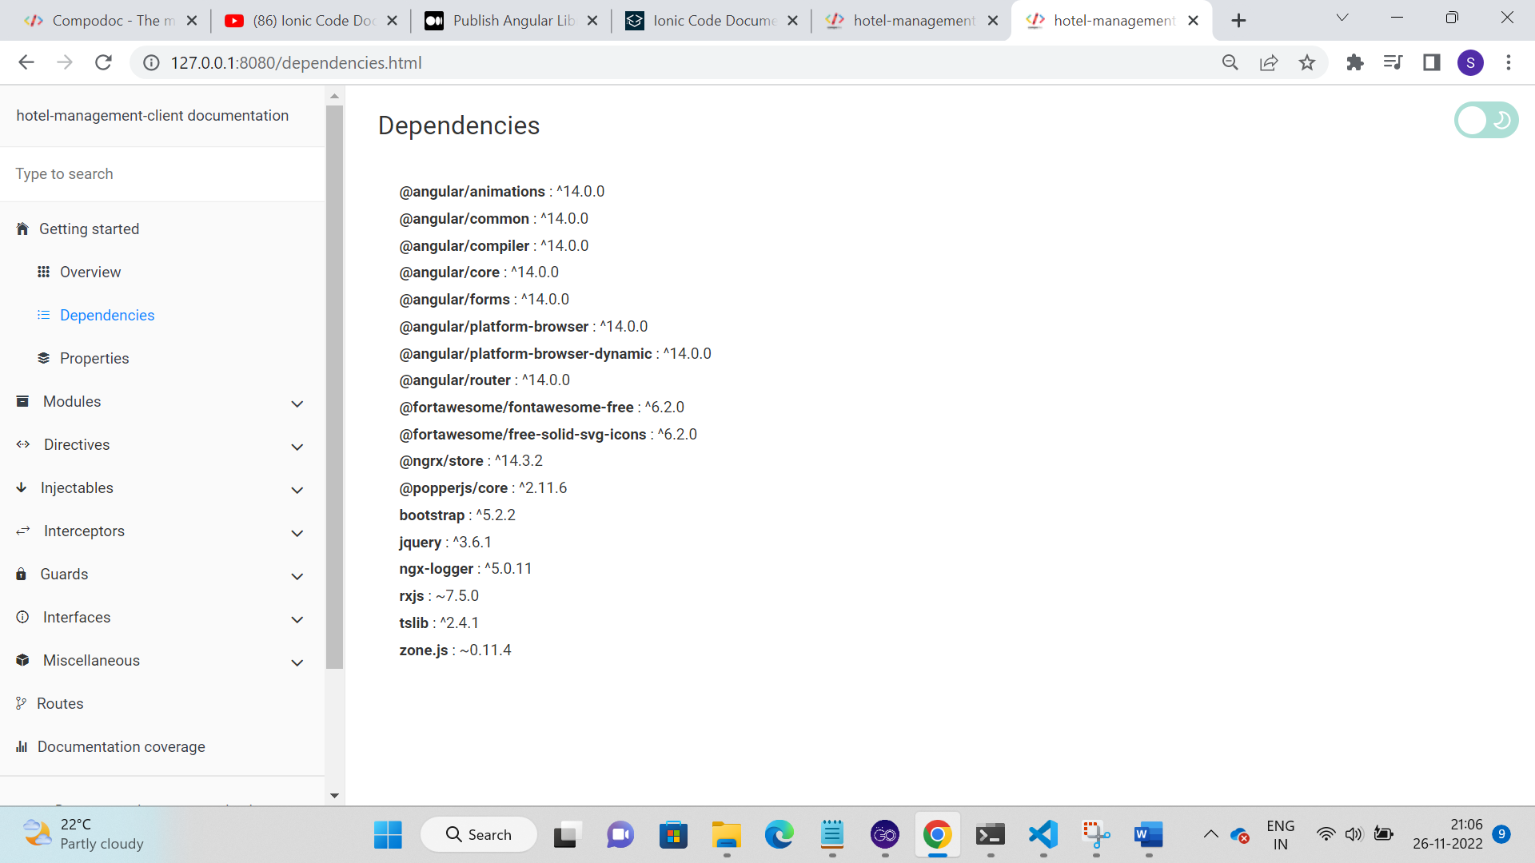

1. **Modules**

Modules display all modules information in the visual format as given below. Modules tab contains all the modules along with its components. It includes the list of declarations, providers, imports and exports of the module.

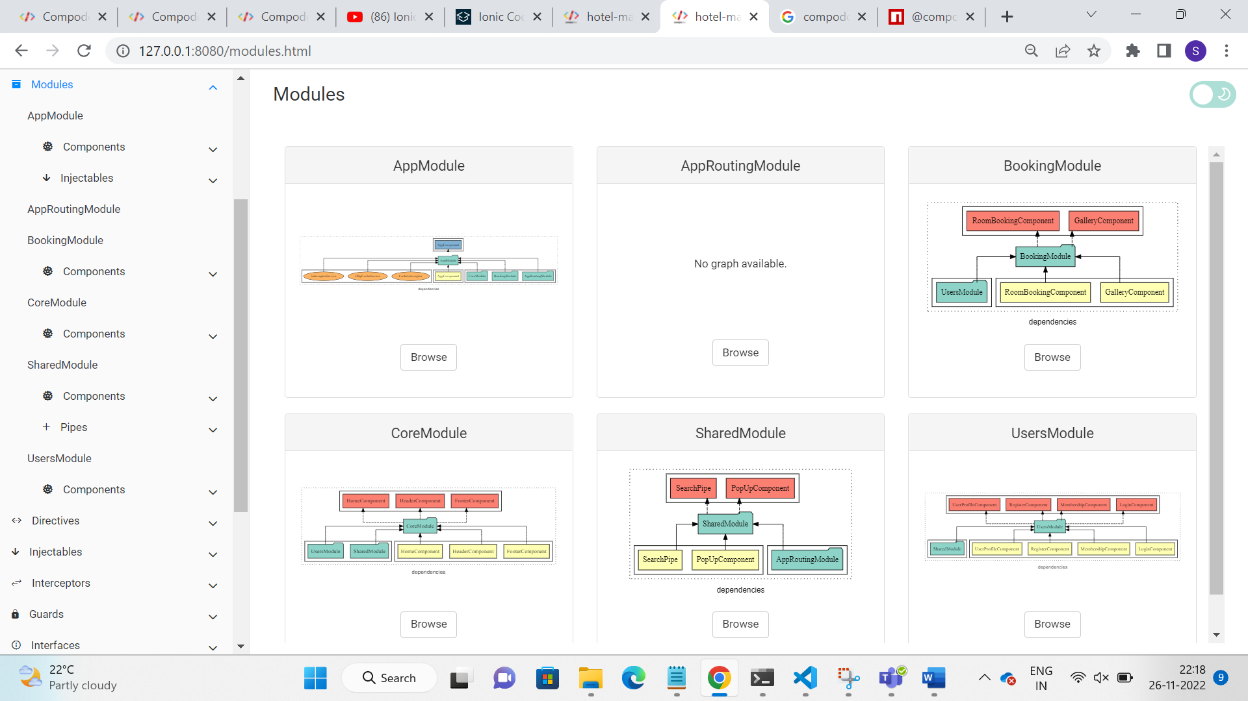

Clicking on Browse button in any of the module opens the page as follows.

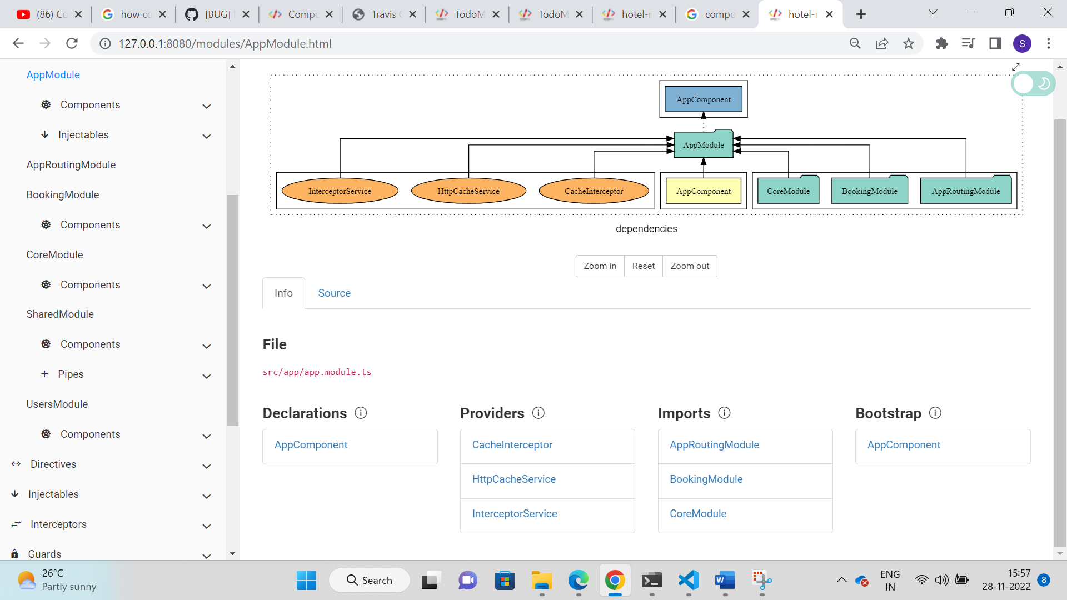

The App module consists of list of providers, imports and one declaration and bootstrap part.

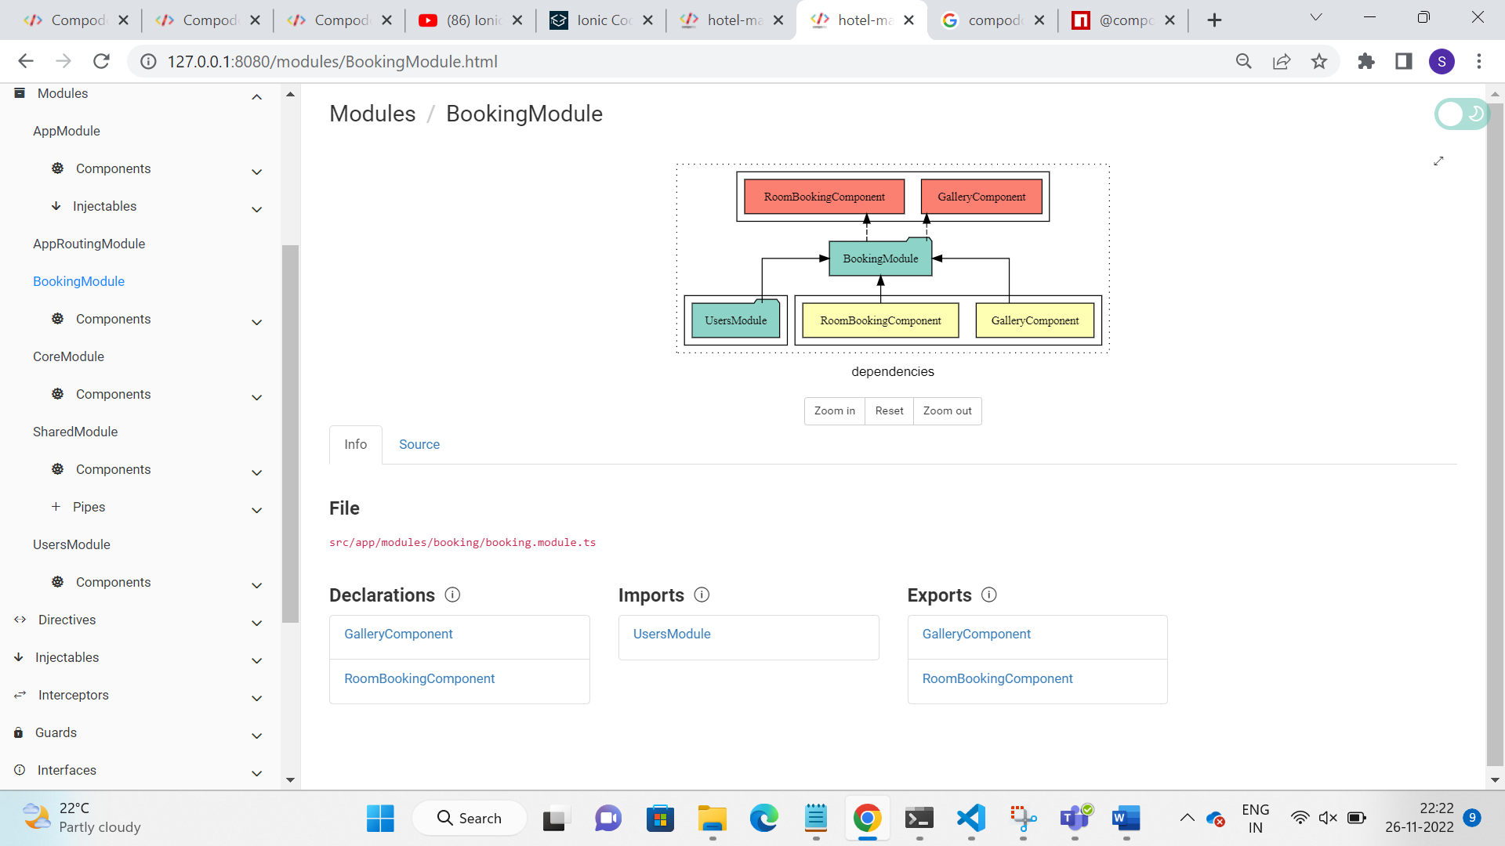

In the above screenshot, Booking Module is opened, and it contains Info and Source tab.

* **Info** – contains the file path, declarations, imports and exports of the components present in the Booking module.
* **Source** – contains the source code of BookingModule.ts

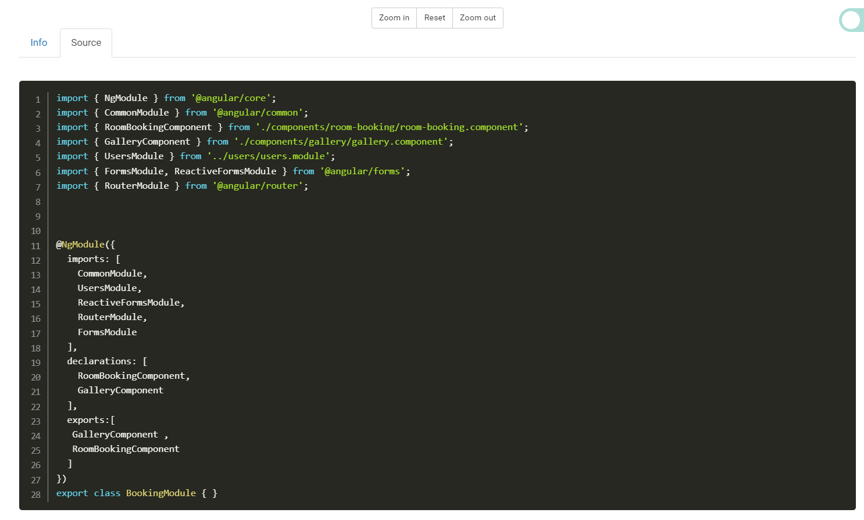

1. **Components**

Click on any component name from left pane. E.g., Clicking Register Component on the left side displaying the documentation of the component on right side. The documentation for component comprises **Info, Source, Template, Styles, DOM Tree.**

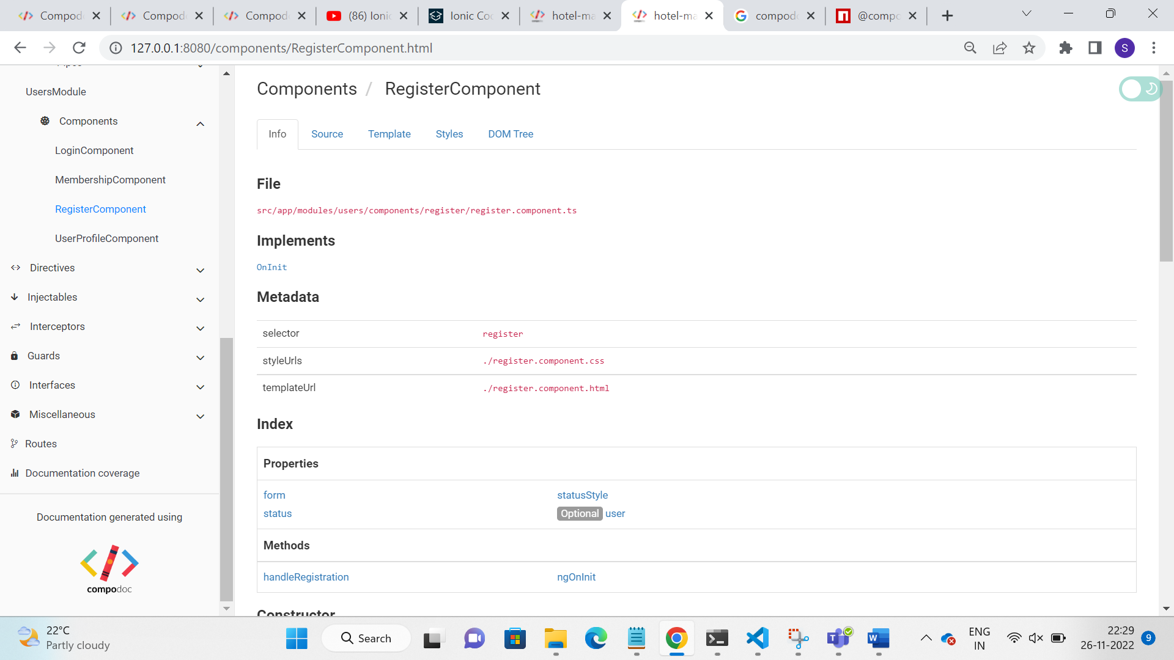

**Info**

The Info tab presents the details of component file path, meta data information, Interface name that implements, Index page properties and methods related with html template, Constructor, Methods, and Properties present in typescript file.

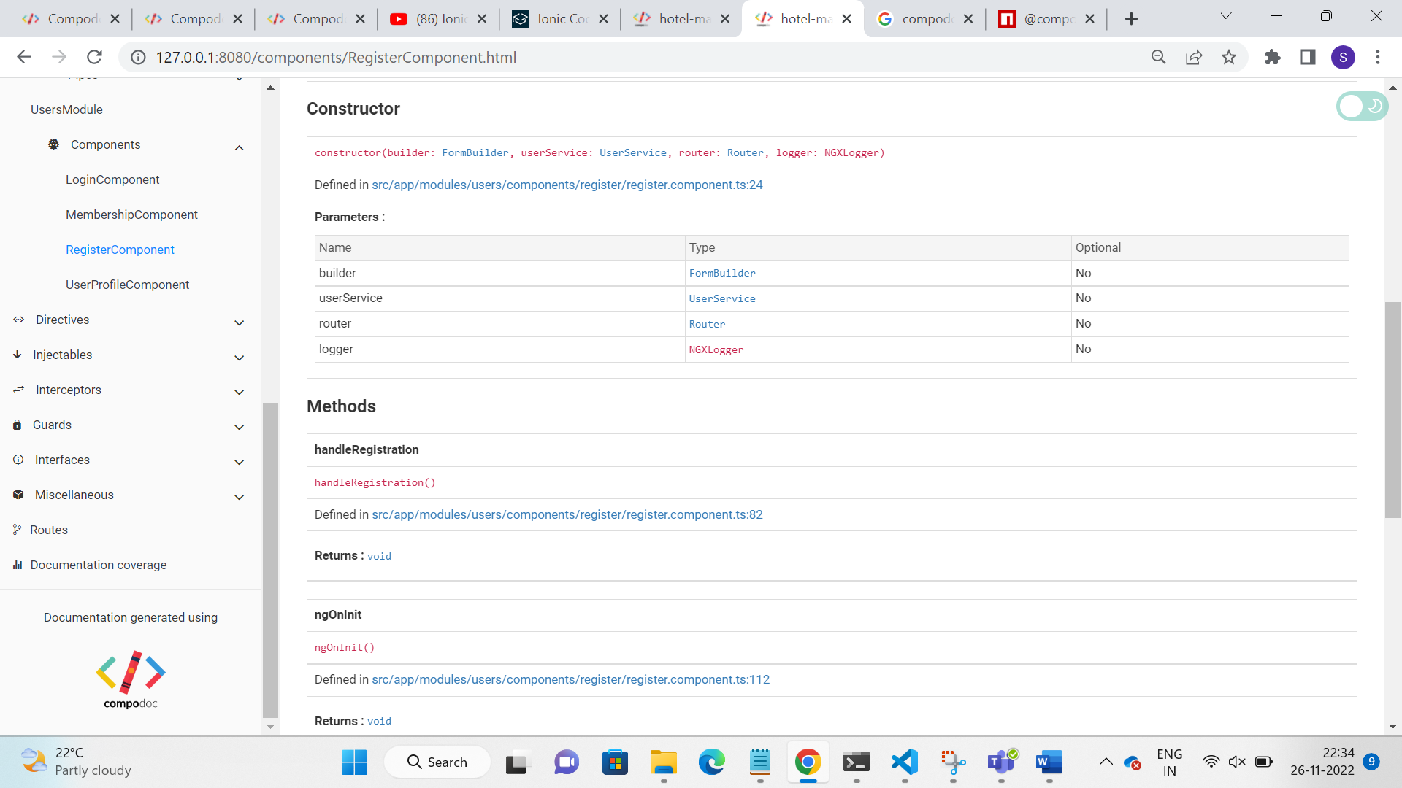

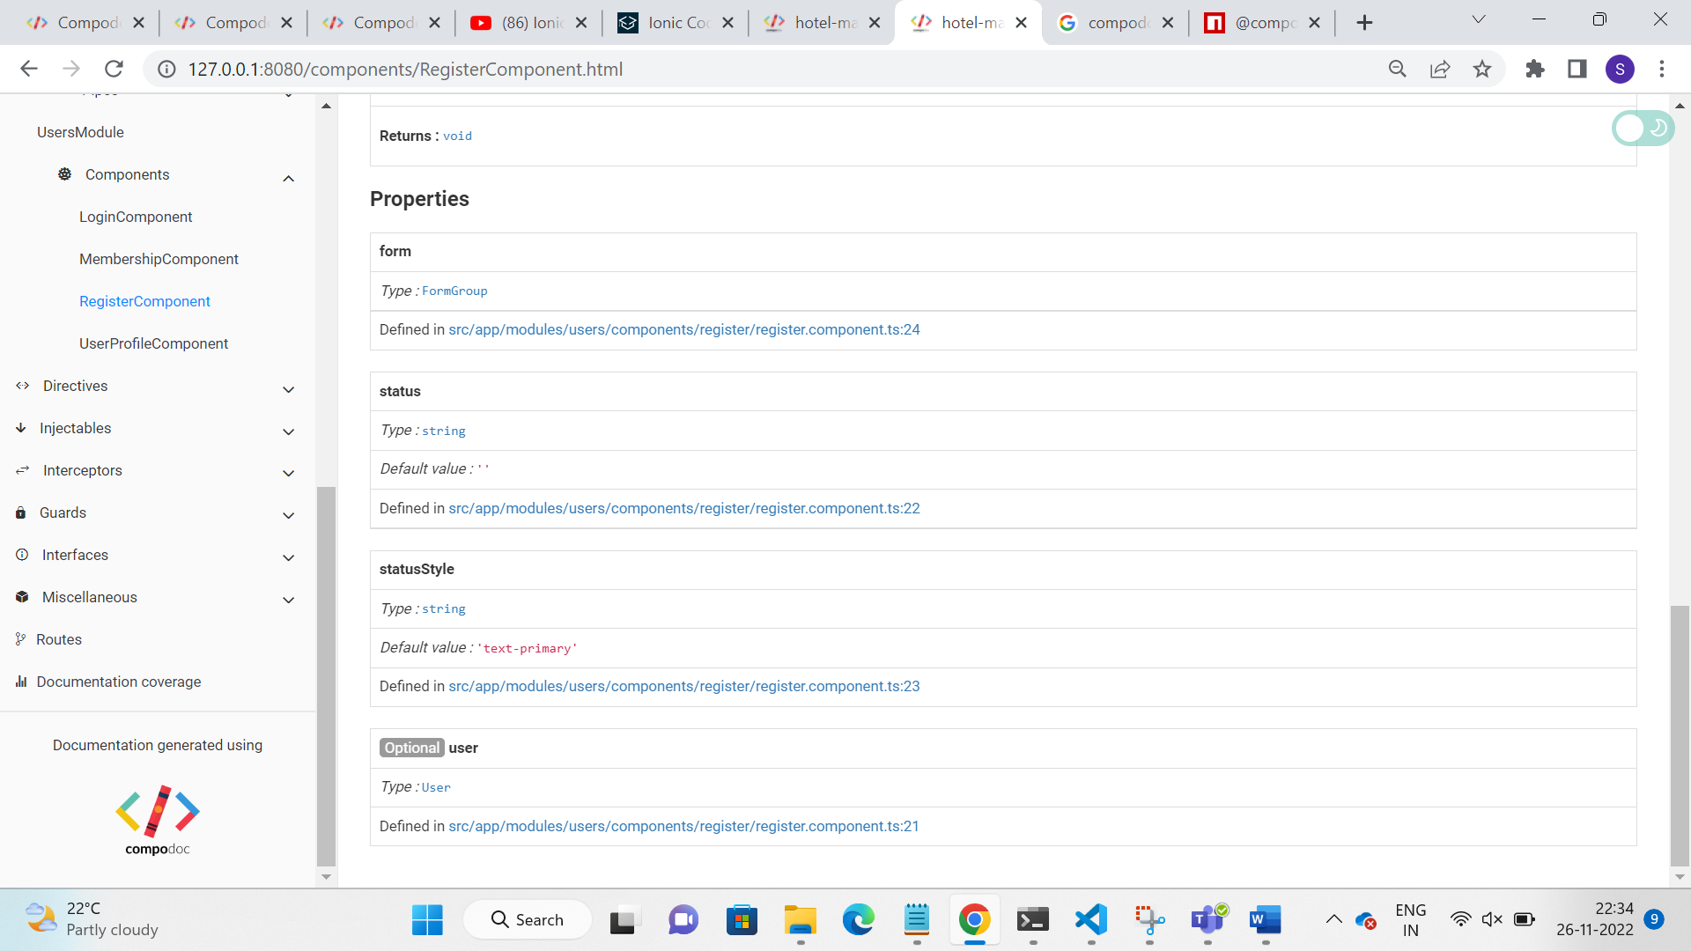

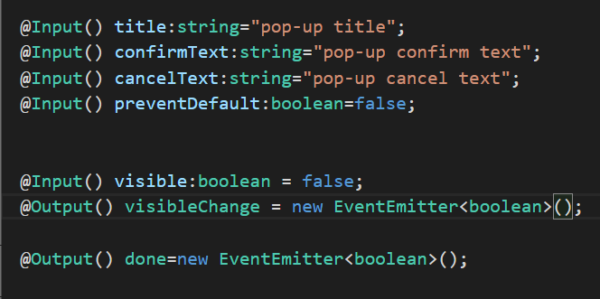

The @Input and @Output properties displayed in the documentation page under Index part and also detailed information given separately under Inputs heading

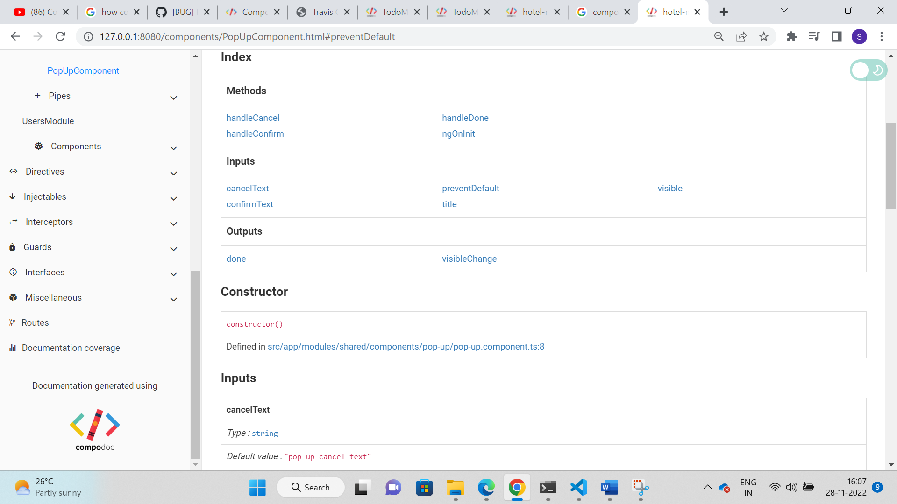

**Source –** Present the source code of the component.

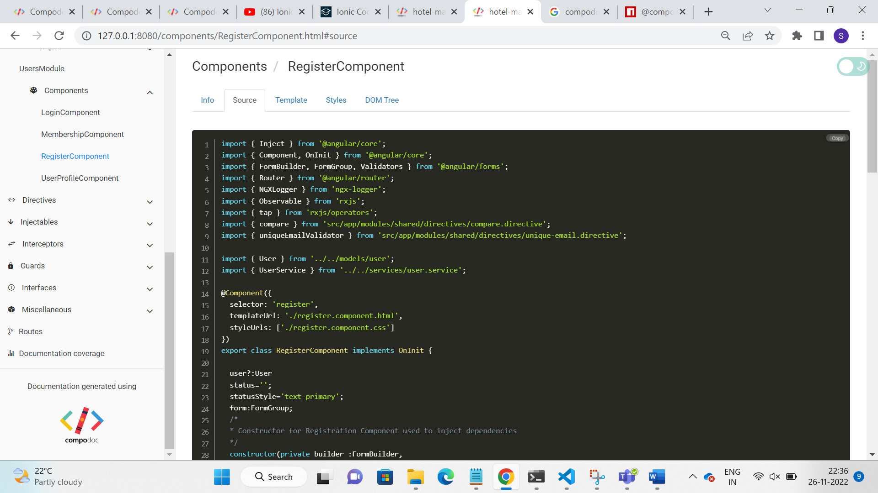

**Template –** present the HTML template file of the selected component

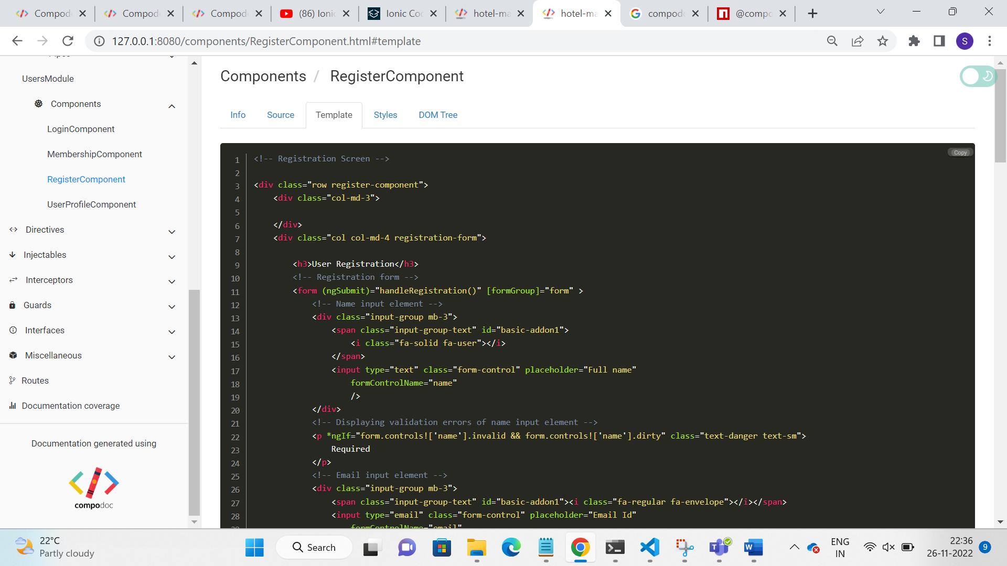

**Styles –** present the CSS style applied on the component

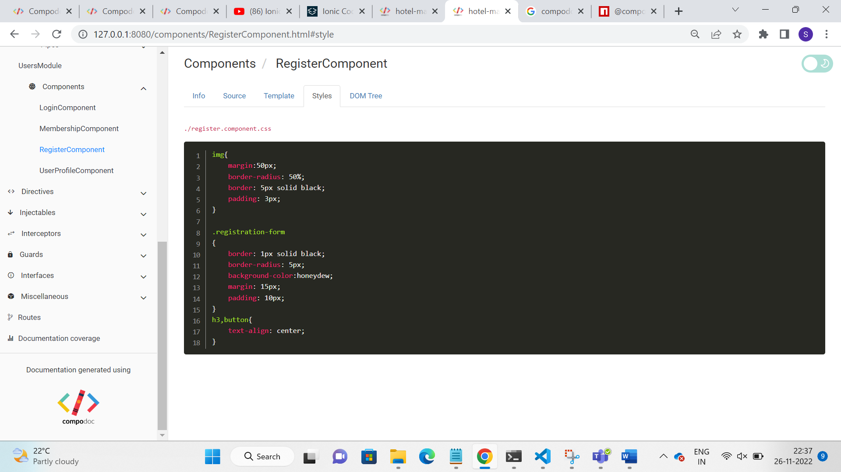

**DOM Tree –** Present the DOM tree for the component with the Legend information and it is useful for understanding the structure.

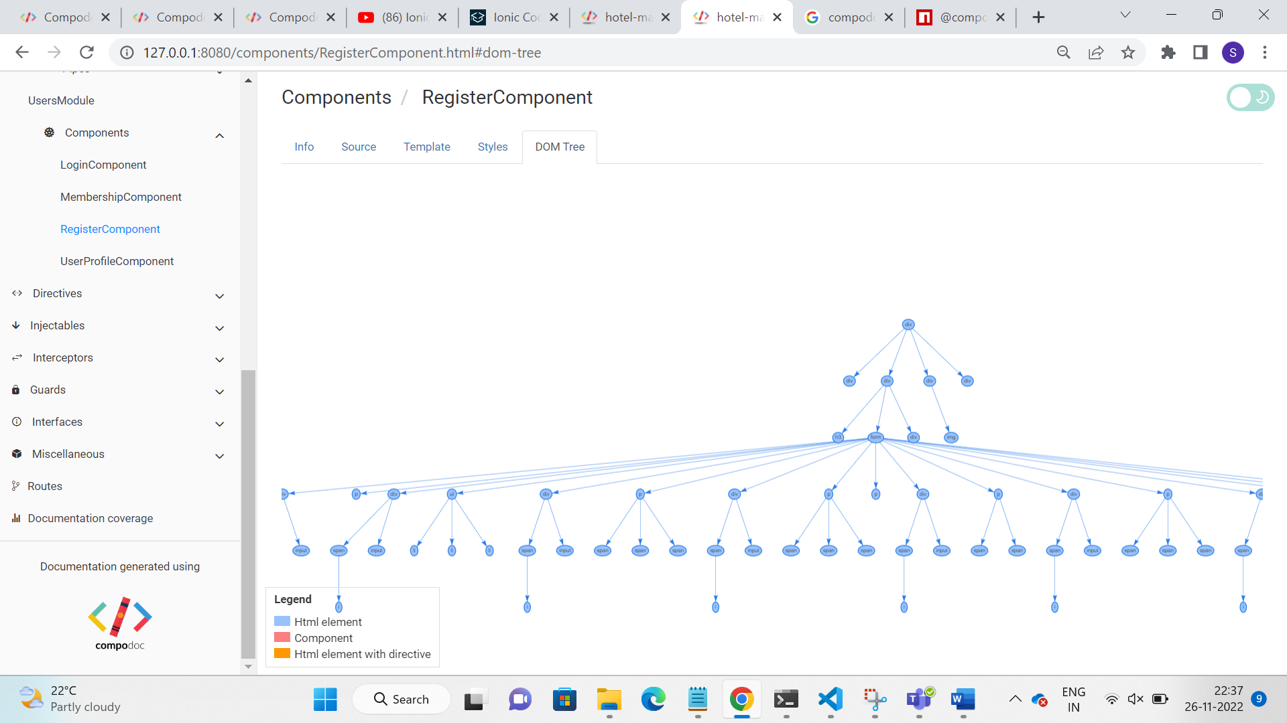

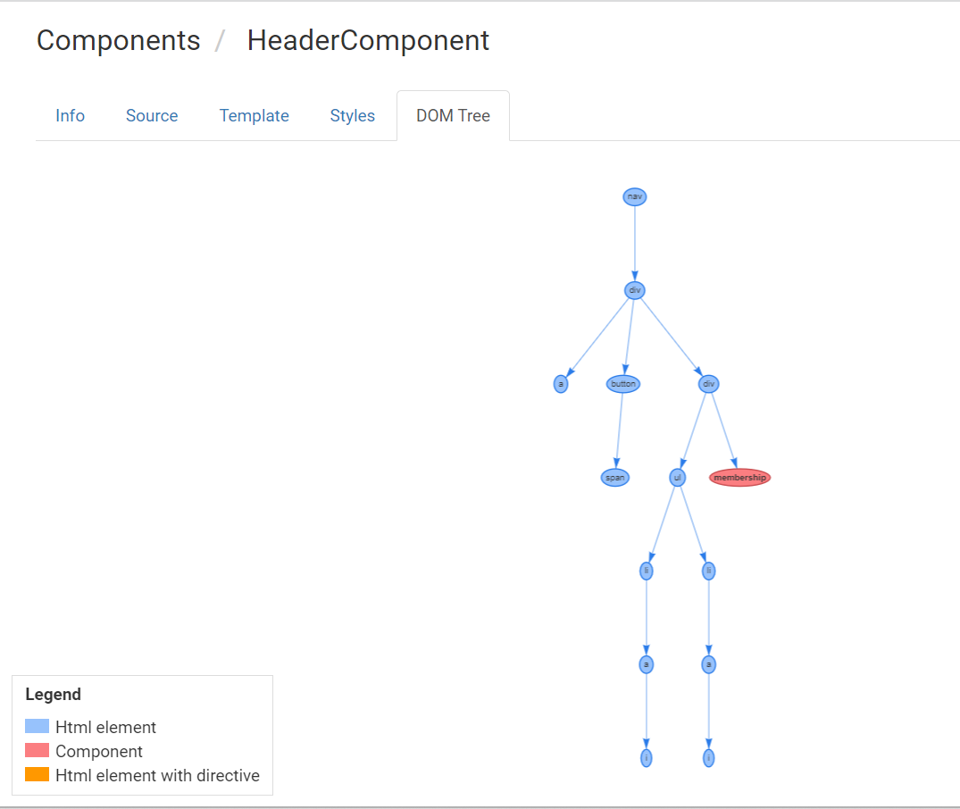

Clicking on the membership cycle in the above DOM tree navigated to the documentation page of membership component.

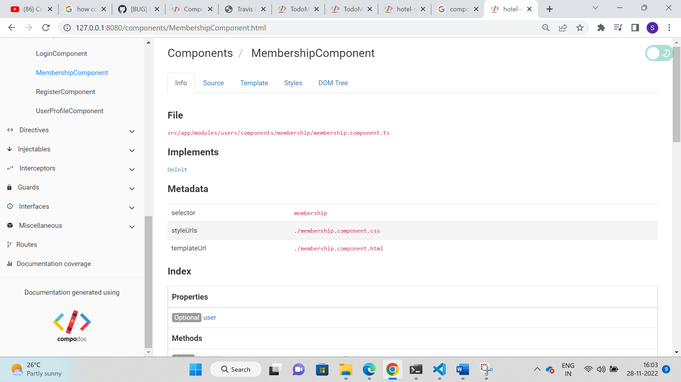

1. **Other Angular Components**

Directives, Injectables, Interceptors, Guards and Interfaces are also presented with their respective details with **Info and Source tab** like **the Info and Source details of the component**.

1. **Routes**

Routes present the routing details (path and its corresponding component) visually as depicted in the below image. Component names are given as hyperlink. So, clicking on the component names navigated to the documentation of the respective component.

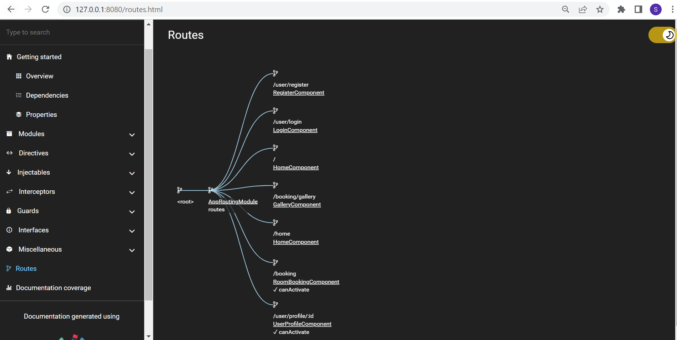

Click on the Home Component in the Routes page, presenting the home component documentation as follows.

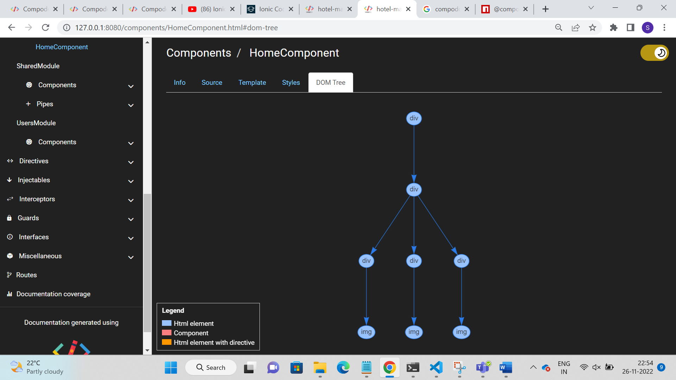

1. **Miscellaneous**

Miscellaneous contains the information related to all the variables used in our application.

Index part comprises the list of variables along with its path. Then detailed information of each variable is presented below the Index part.

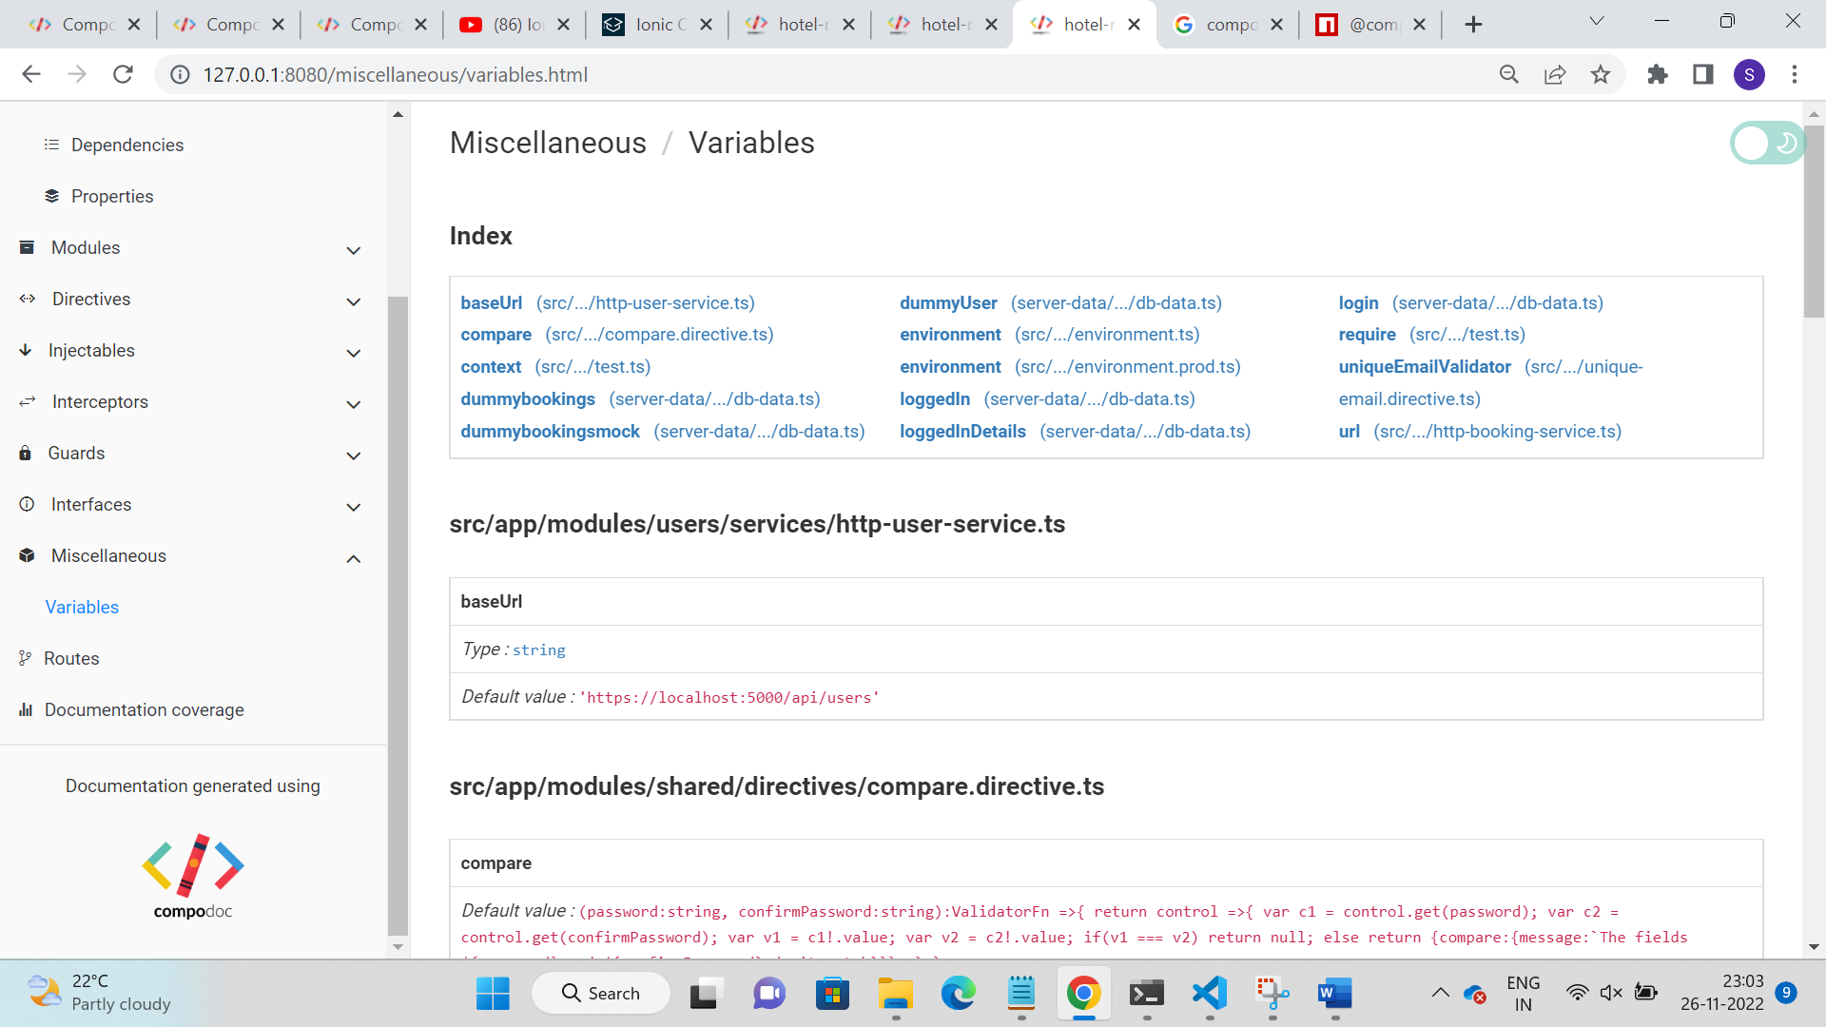

1. **Comments**

Compodoc use Typescript AST (Abstract Syntax Trees) parser and its internal APIs, so the comments have to be JSDoc Comments.

**Supported type of comments**

/**

     * This method sends http get request to the server

     * @param{string} email

     * @returns Observable of user

     */

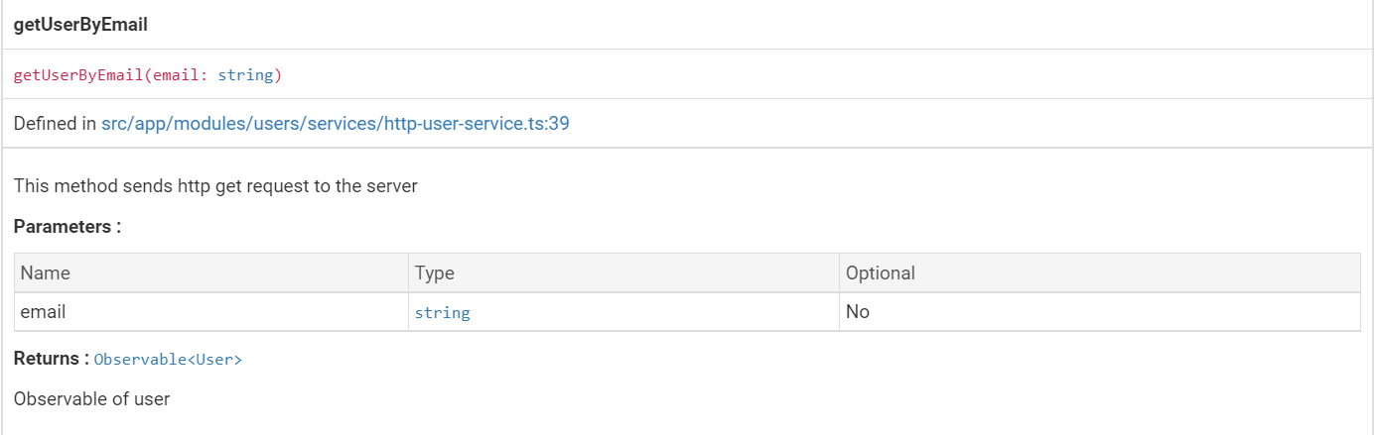



This type of comments is supported in Compodoc and it is presented in documentation. In the above image the comments are displayed as description of the method getUserByEmail.

* If you add blank line inside comments, then new line will be generated in the compodoc documentation and if you don’t leave a blank line inside comments everything will come in a single line in the documentation.

Example:

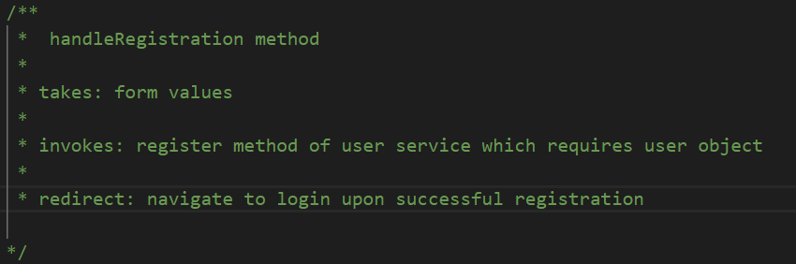

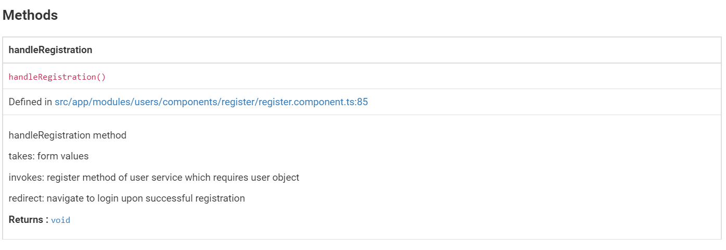

**Unsupported Comments**

Comments like /* */ and // are not supported by compodoc.

Example:

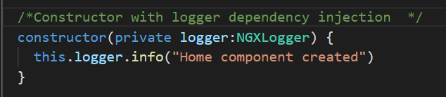

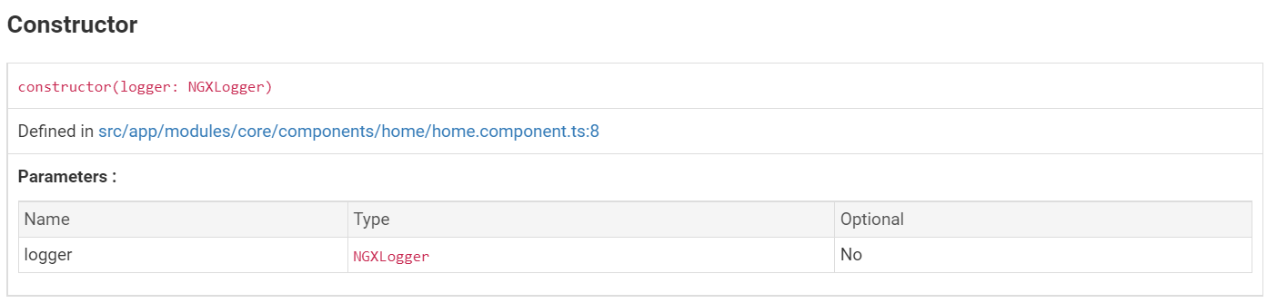

The comments /* */ are not supported hence they are not added in compodoc documentation.

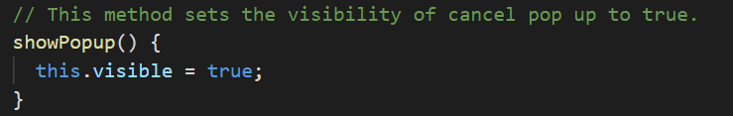

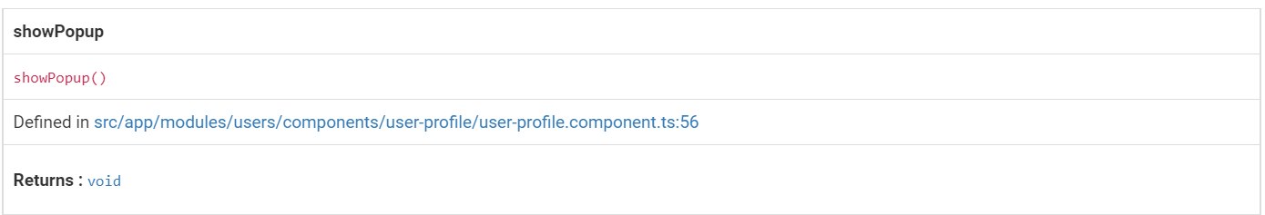

Similarly, comments started with // are also not documented as it is not supported by compodoc.

1. **JSDoc Tags**

Compodoc supports the following JSDoc tags.

* @param {Type} Name Description – used in method comments
* @returns {Type} Description - used in method comments
* @ignore, @internal – To prevent the code to be appeared in the documentation

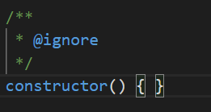 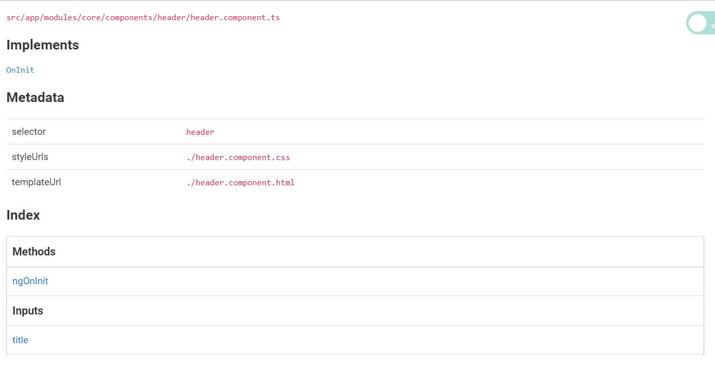

As @ignore is added in the comments the constructor is not presented in the documentation.

But if you remove the comments then the constructor is documented in compodoc as depicted below.

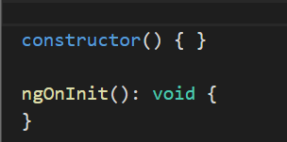 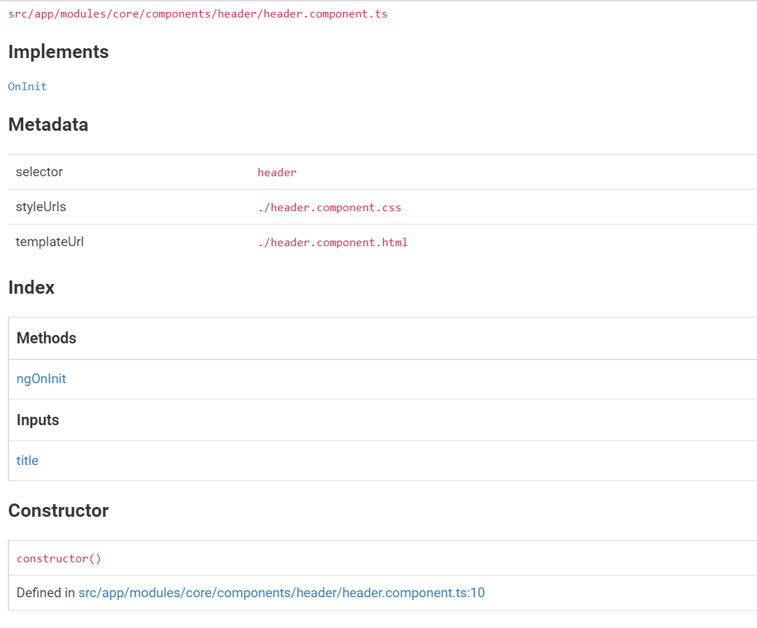

We can also add description for @param as below which displays the description in the documentation.

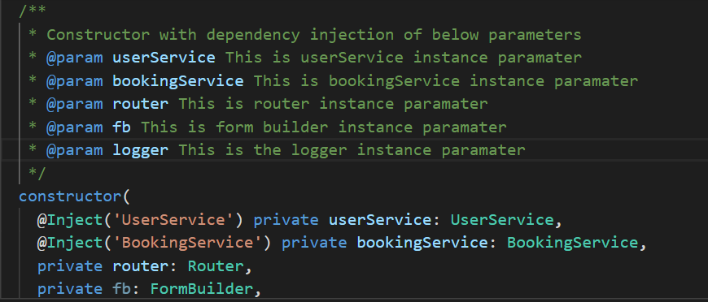

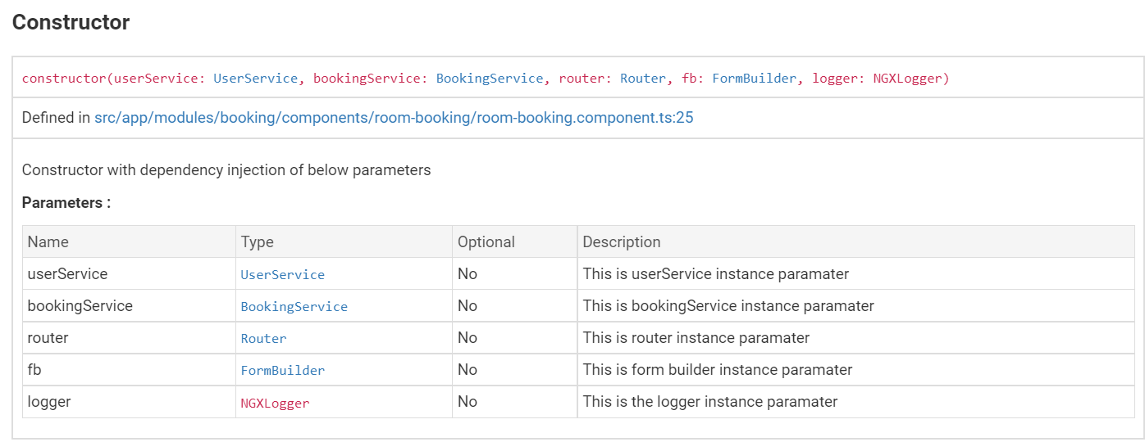

1. **Documentation Coverage**

Documentation coverage is calculated only for all statement of the file, even decorators. Private functions are not part of the calculation. It is table with File, Type, Identifier, Statements columns.

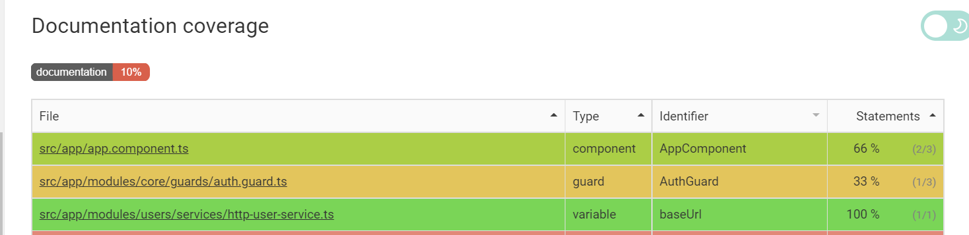

By adding the proper comments and JSDoc tags the documentation coverage can be increased.

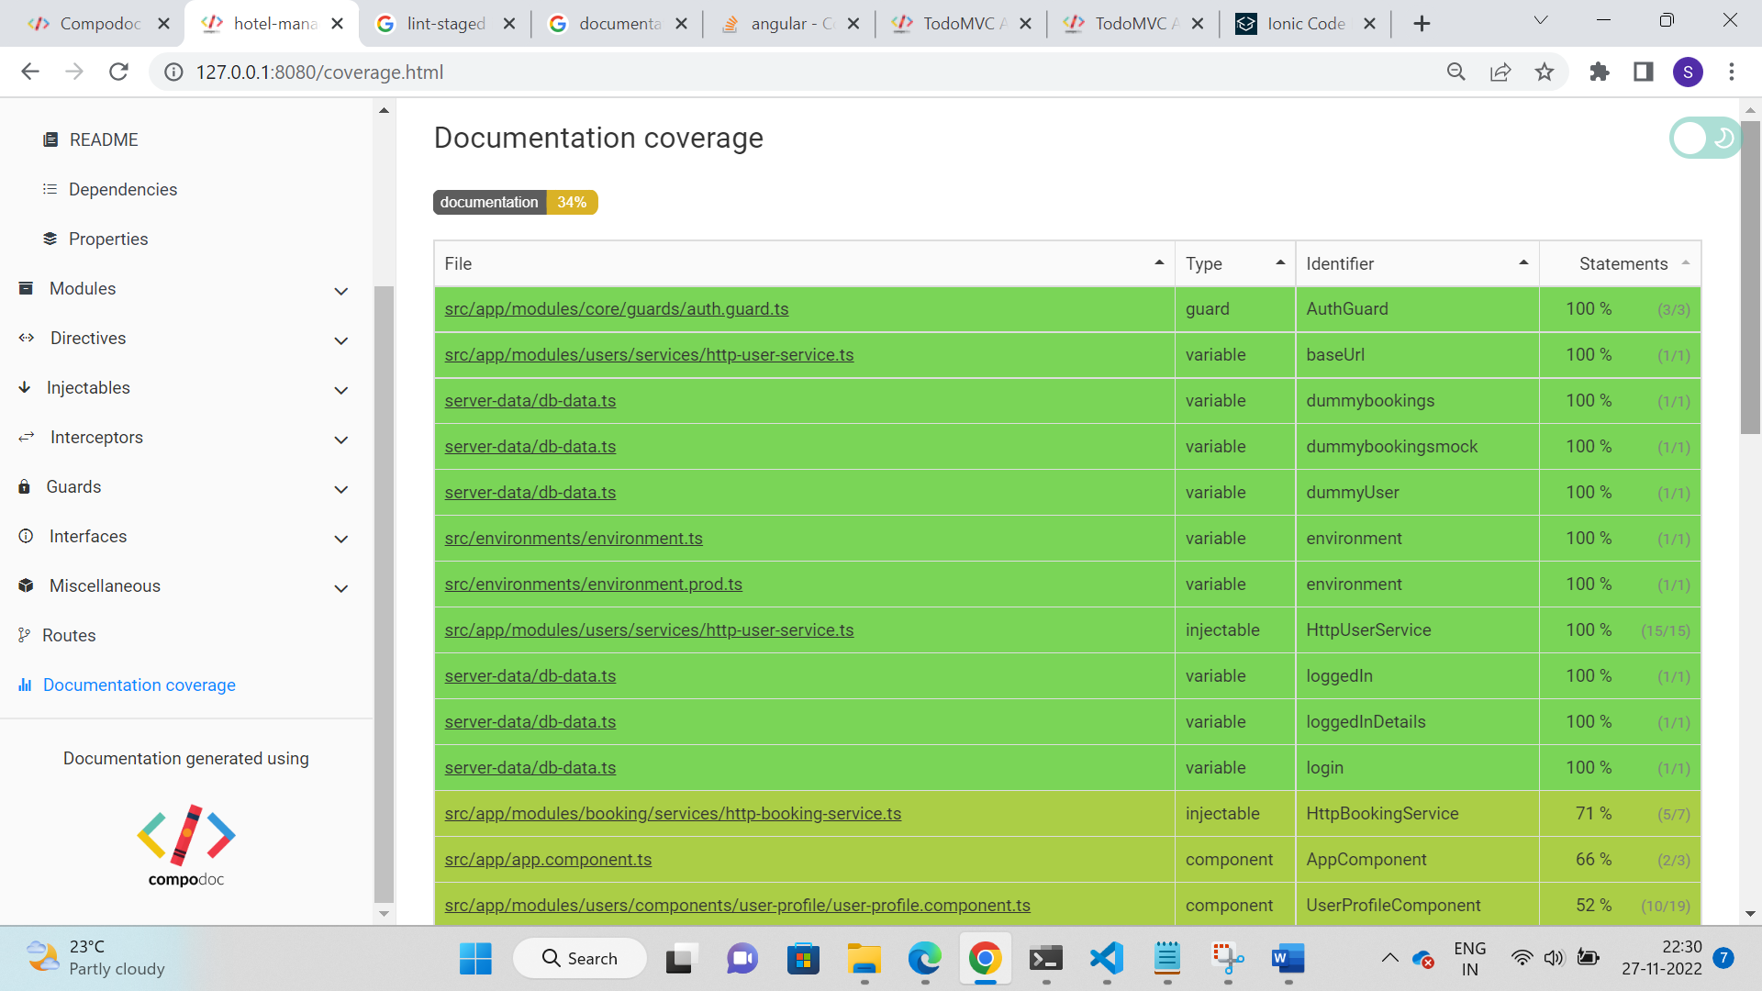

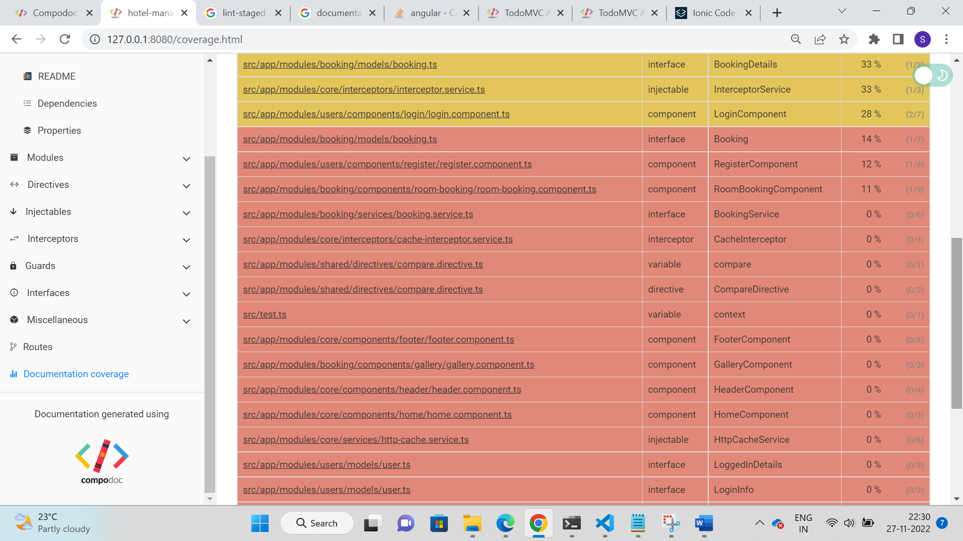

Documentation coverage increased to 68%.

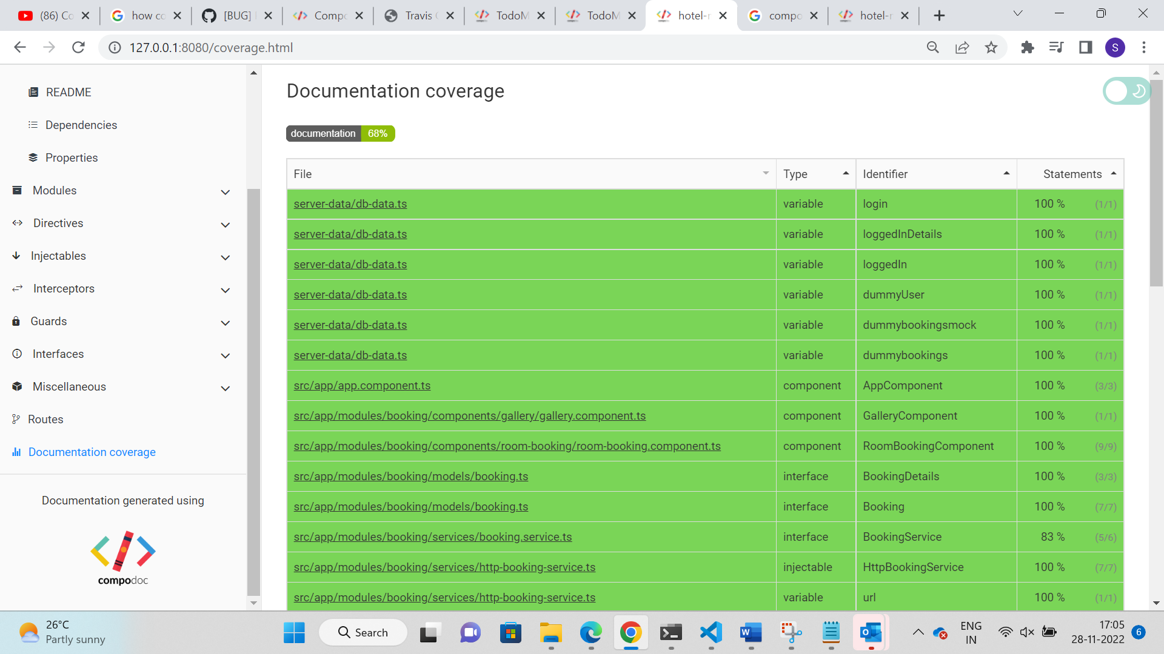

# ADDITIONAL FEATURES

**Themes**

Compodoc supports various themes, and they are listed below.

1. Gitbook (Default)
2. Read the Docs
3. Vagrant
4. Laravel
5. Postmark
6. Material Design
7. Stripe

To change the default theme to another theme, add –theme [theme name] in package.json file.



The result looks like below for readthedocs theme

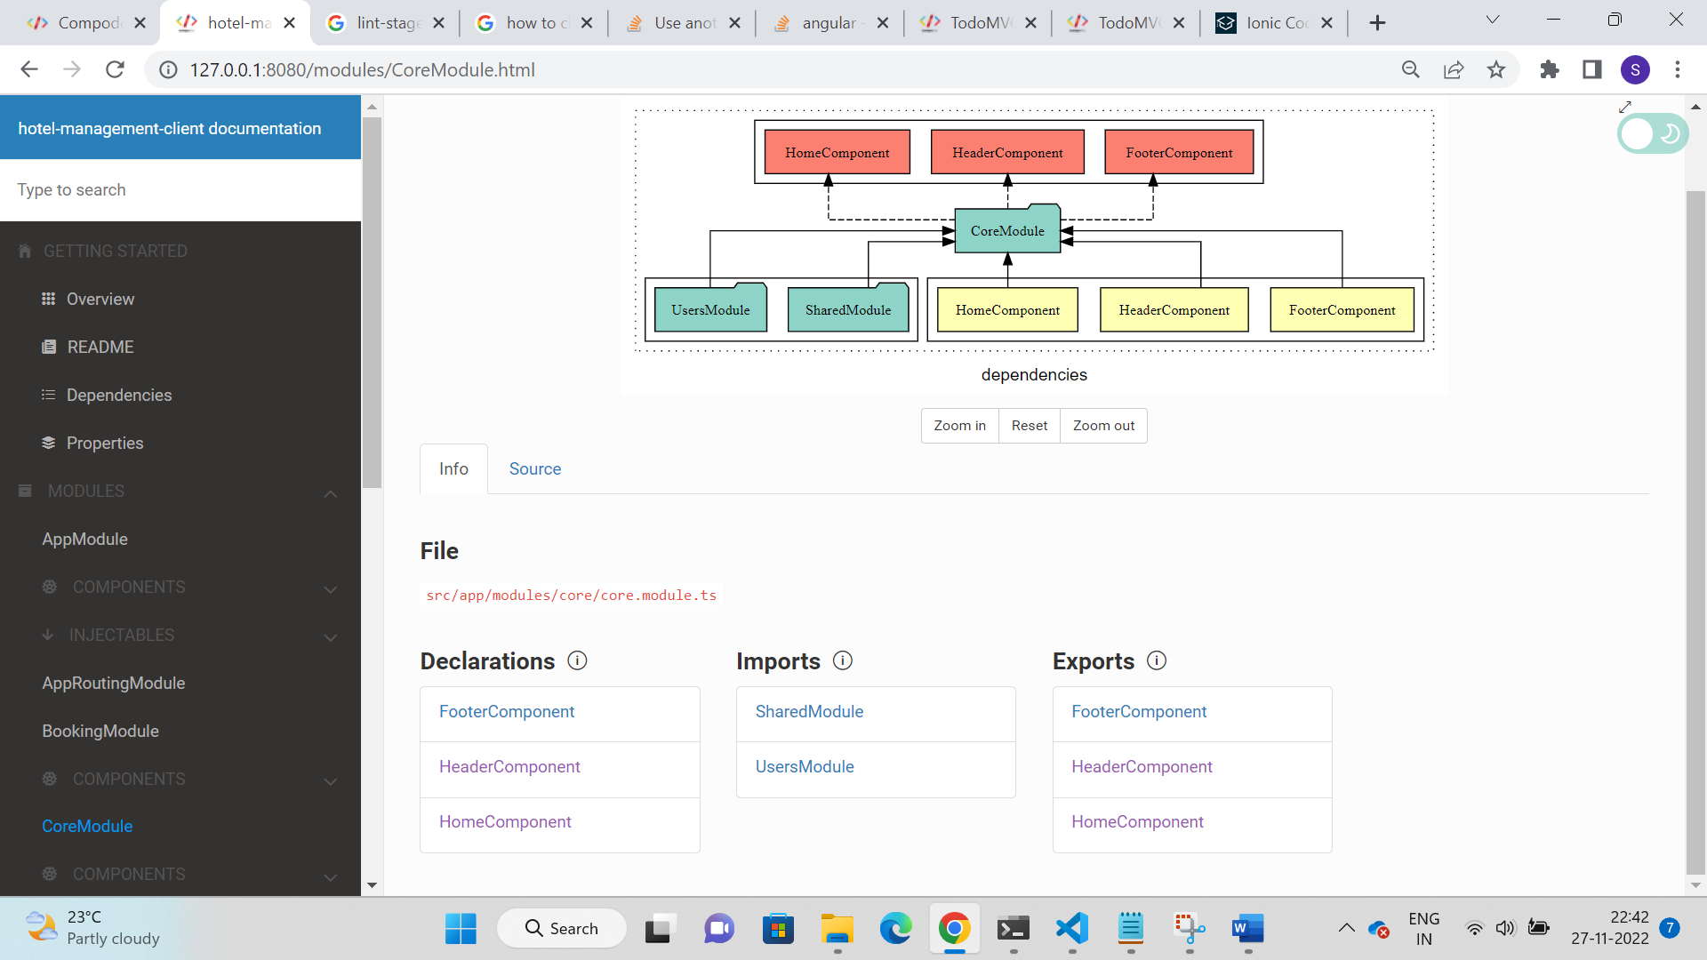

For Postmark theme, add the below line in package.json



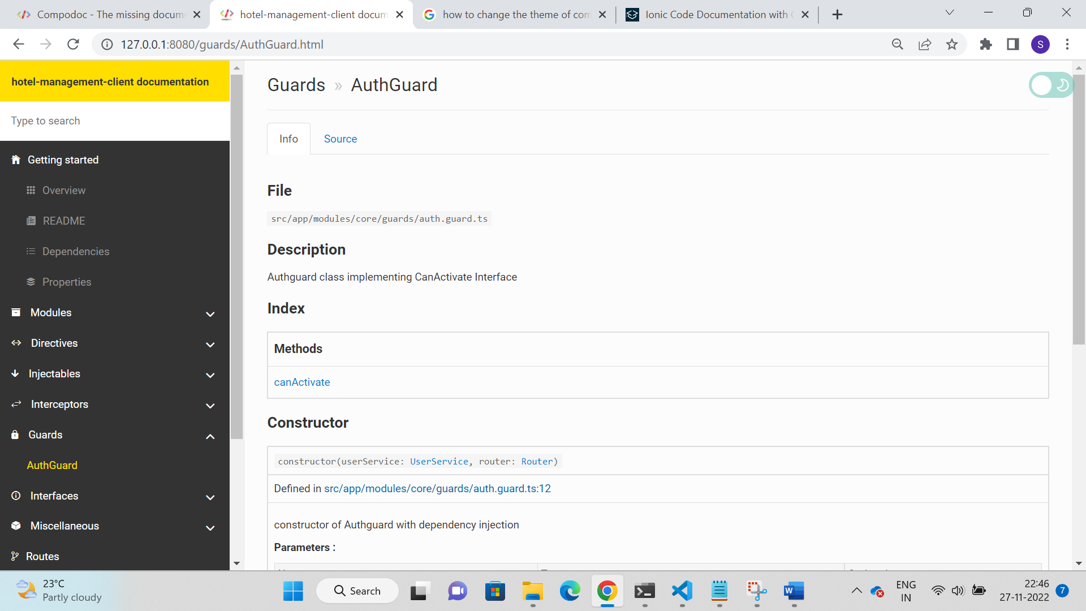

**Live Example Tab**

<example-url> …url… </example-url> tag allows to add live demo examples for components, directives and services.

Example: Adding Examples tab in Gallery Component

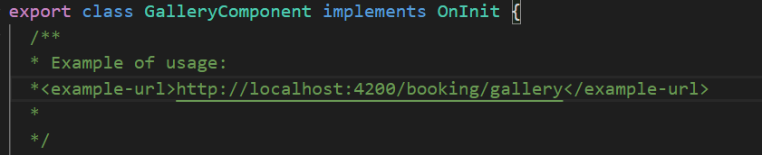

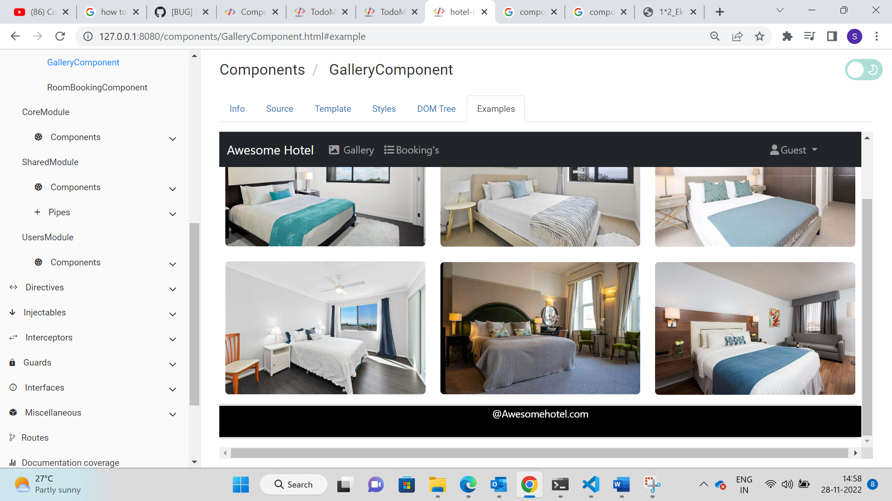

Examples tab is added, and the web page is loaded inside. If the application runs on the server, we will get this page otherwise the web page will not be loaded.

# Conclusion

Compodoc which is a third-party library goes through all our code including comments, JSDoc tags and generate documentation in HTML format. It is really a powerful tool to understand the project modules as it renders the details in visual format. It also provides many features such as example tab configuration, different themes, offline support and more. Each team member can get a clear view of the architecture through this compodoc documentation tool.